**UNIVERSITY OF BOHOL**

Tagbilaran City, Bohol, Philippines

[www.UniversityOfBohol.com](http://www.universityofbohol.com) (038) 411-3484, Fax No. (038) 411-3101

Department : **COLLEGENGINEERING & TECHNOLOGY**

*Name: John Claidy Ken O. Taguran*

*Date of submission: Feb 15, 2024*

*Course and Year Level: COMPE 3*

***Performance Evaluation:***

*Direction: Research and answer of the following:*

1. *What is a central processing unit (CPU)?*

The CPU is the main processor that carries out instructions to a program and has the basic arithmetic logic, controls, and input/output operations that is being specified by the instructions given. The CPU can be found in every electronics device.

1. *Research on the history of the Microprocessors?*

In the 1st generation of the era of microprocessors, INTEL made the first 4004 microprocessor in 1971 that would run on a clock speed of 108Khz and represents signed numbers. It isn’t the best use for typical arithmetic calculations but it was enough to use for controlling devices.

In the 2nd generation, the intel 8008 was created in 1972, this microprocessor is able to perform 8-bit word size, this microprocessor still does signed numbers with a bigger range that is enough for controlling applications during that time. Other microprocessors in that time would be released such as the Motorola 6800 and the Zilog Z-80 which would become popular but also became costly for its time.

The 3rd generation would get a new 16-bit microprocessor that would give a signed number range of -32,768 to +32,767 which was an incredible upgrade from the previous generation. Not only it would be used for controlling applications but, it would also be used for number crunching operations.

The 4th generation, the 80’s would introduce new technology which would be having a 32-bit processor that would crunch more numbers, perform more calculations, control, and new ideas onto applications which is a big upgrade from the 3 generations it came. The Intel 80386 would be one of them. Being made by HCMOS fabrications, the 80386 would become the microprocessor to have a significant range of ±2×109. Not only that, but if floating point notation is being used on the program, it could even represent much larger numbers into to the program or device. In the 90’s they would upgrade it again to the Intel 80586 or as we can now remember, the Pentium processor. Being able to perform calculations and executing instructions faster than previous generations. Being released on 2000’s, it would have 42 million transistors in a clock speed of 1.5Ghz. It would be sold around the world.

The 5th generation would have faster and high-performance processors in which the 64-bit would be made. The 64-bit would be used till this day as it can do tasks than previous generations and would handle great in day-to-day tasks and operations, especially on initiating executions and calculations at the same time.

1. *Who invented Microprocessor?*

The inventors of the microprocessor are Federico Faggin, Marcian Hoff, Masatoshi Shima, & Stanley Mazor.

1. *List all Intel Microprocessors from the beginning until the latest model.*

| **Microprocessors** | **Year of Invention** |
| --- | --- |
| Intel 4004/4040 | 1971 |
| 8008 | 1972 |
| 8008 | 1974 |
| 8085 | 1976 |
| 8086 | 1978 |
| 8088 | 1979 |
| 80186/80188 | 1982 |
| 80286 | 1982 |
| Intel 80386 | 1986 |
| Intel 80486 | 1986 |
| Pentium | 1993 |
| Intel Core 2 | 2006 |
| Intel Core i3, i5, i7, i9 | 2007 - Present |

1. *What is Arithmetic Logic Unit and where is it found?*

An Arithmetic Logic Unit is a unit which carries out arithmetic and logical operations. It would be located in the circuit board which is embedded within the CPU.

1. *What is the symbolic representation of an ALU?*

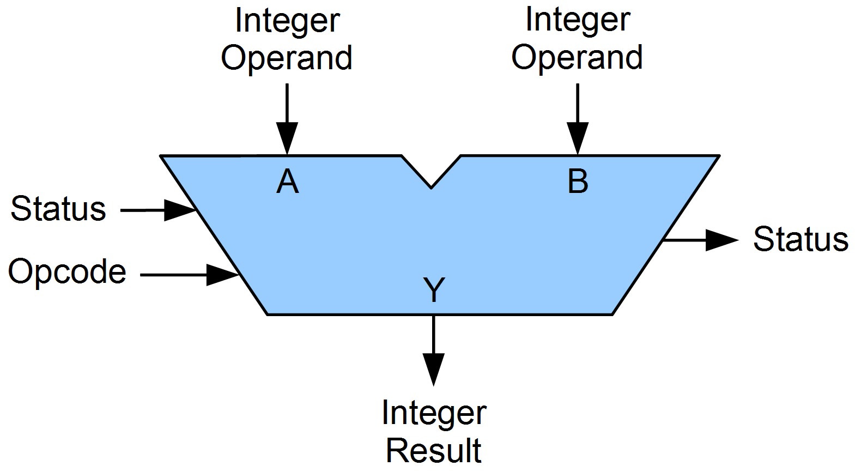

1. *What are signals under Arithmetic Logic Unit and explain each of it?*

| 1. Operand Inputs | A value or expression as input for an operator, symbol, or function that performs an operation on the operand. In result, the operator would manipulate operands. |
| --- | --- |
| 1. Operation Selector | Known as an opcode, is an instruction which is part of that processes what operation given is needed to be perform. |
| 1. Carry-In | An extra bit in the ALU that represents a potential carry from a previous operation, used in addition and subtraction for efficiency. |
| 1. Carry-out | A flag set to 1 when the sum exceeds the capacity (overflow) or carries over to the next bit in addition. Helps detect errors and propagate carries. |
| 1. Zero Flag | Set to 1 if the result of an operation is zero, 0 otherwise. Used for conditional branching in programs, improving efficiency and decision-making. |
| 1. Sign Flag | Indicates sign of results after the Arithmetic operations is given. |
| 1. Overflow Flag | Signals when the result of an operation exceeds the representable range of the output register. |
| 1. Enable | Controls whether specific functionalities are active on the ALU. |

1. *What is the difference of CPU and ALU?*

| The difference between shows that: | |
| --- | --- |
| The CPU just handles instructions and executes them in order to operate and run application and programs on a computer | The ALU in the other hand is just an electronic circuit that would perform arithmetical and logical operations. |

1. *Give example of the following other than the given on the concept notes:*
2. *Carry-out*

Carry-out

1101

+ 1011

-------

10100

1. *Negative*

Negative

1101 (negative 3)

+ 0101 (positive 5)

-------

1 0010

1. *Overflow*

Overflow

0110 (6)

+ 0111 (7)

-------

1 1101

1. *Parity*

If parity is even, example in number of 1s in 1010 is 2, the parity bit would be 0. If its odd it would be 1.

1. *Research on the following and explain its functionalities:*
2. *Arithmetic Operations,*

The functionalities given include:

Addition – process of adding two numbers to get the sum.

Subtraction – process of finding the difference but subtracting two numbers given.

Multiplication – process of repeated additions to multiply numbers.

Division – splitting numbers into equal parts or getting the quotient of two numbers.

Modulo – returns remainder as it can be determined if a number is even or odd.

Increment – involves increasing value of variable by one.

Decrement – involves decreasing value of variable by one.

1. *1’s Complements*

The functionalities given include:

Represents a signed binary number to perform various operations such as addition, and subtraction. Both would represent positive (+) and negative (-).

1. *2’s Complements*

Represents signed numbers & would perform arithmetic operations.

1. *Increment and Decrements*

Increment ++ - Increases operand value by one.

Decrement -- - Decreases operand value by one.

1. *Bitwise Logical operations*

Operates 2-bit patterns of equal lengths by positionally matching their individual bits.

*Note: You can write your answer in to any sheet of paper or make a word document to make it easier and send it back through our Google classroom.*

